 |  | Government of the People’s Republic of Bangladesh  Narail District Jail  Narail  www.prison.narail.gov.bd |  | 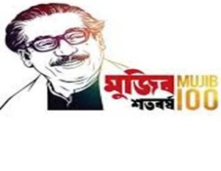

Memo no-58.04.6500.144.05.003.22- Date-15.09.2022

Re-Tender Notice

This is to notify all concern that the following tender is invited in the national e-GP Portal.

SL no | Tender ID No | Name of Work | Publishing, Closing Date & Time | Procurement Method
01 | 733685 | Imported High Quality Moshuri Dal (Mota) for the period of October’2022 to March’2023 | 18-Sep-2022 10:00:00 ,  26-Sep-2022 11:00:00 | LTM
02 | 733687 | Imported High Quality Cholar Dal for the period of October’2022 to March’2023 | 18-Sep-2022 10:00:00 ,  26-Sep-2022 11:30:00 | LTM

This is an online tender where only e-Tender will be accepted in the national e-GP portal and no offline/hard copies will be accepted.

To submit e-Tender registration in the national e-GP portal
(http;/www.eprocure.gov.bd) is required. Further information and guidelines are available in the national e-GP System portal and from e-GP help desk (helpdesk@eprocure.gov.bd)

Md. Mujibur Rahman
BJ-02729900219
Jail Superintendent
Narail District jail
02-477773648
jailsuper_narail@yahoo.com

